An Amazon Machine Image (AMI) is a pre-configured template that contains the necessary information to launch an instance on Amazon EC2. It includes the operating system, application server, and applications, along with configurations such as launch permissions and block device mappings.
Key Components of an AMI:
- Root Volume Template: Defines the operating system and installed applications.
- Launch Permissions: Control which AWS accounts can use the AMI to launch instances.
- Block Device Mapping: Specifies the storage volumes to attach to the instance upon launch.
Types of AMIs:
- Public AMIs: Available for use by any AWS user.
- Paid AMIs: Registered with Amazon DevPay; users subscribe to access them.
- Shared AMIs: Private images shared with specific AWS accounts.
Creating a Custom AMI:
To create an AMI from an existing EC2 instance:
- Stop the Instance: In the EC2 console, select your instance, choose "Instance state," and then "Stop instance."
- Create the Image: After stopping, select "Actions," then "Image and templates," and choose "Create image."
- Configure the Image: Provide an image name and description, then select "Create image."
This process captures the current state of your instance, allowing you to launch new instances with the same configuration.
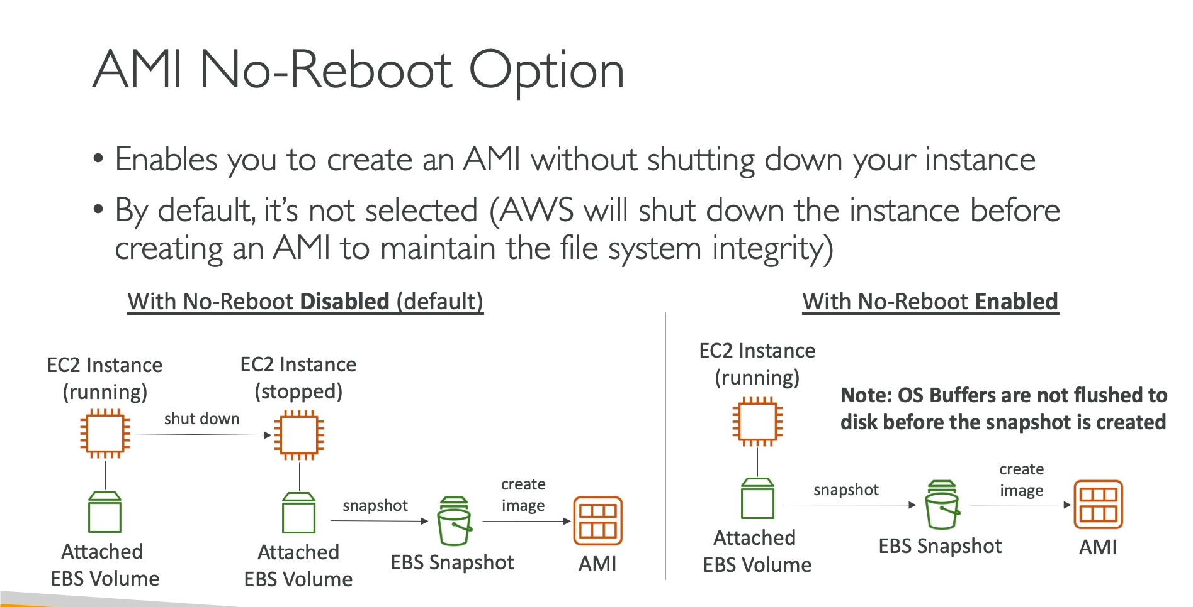

Amazon EC2 Image Builder is a fully managed AWS service that simplifies the creation, customization, and management of Virtual Machine (VM) and container images for use on AWS or on-premises. It automates the image creation process, ensuring that images are up-to-date and compliant with your organization's security standards.
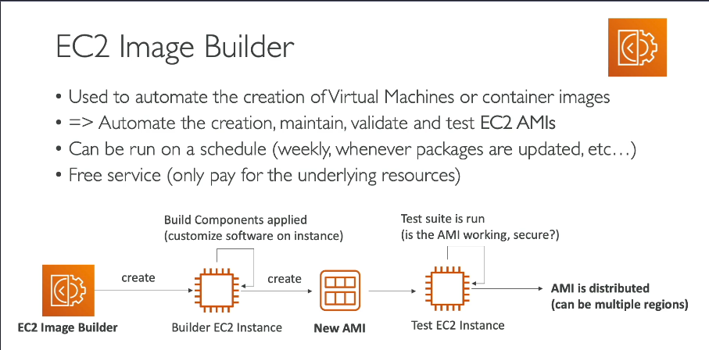

AWS Systems Manager:
AWS Systems Manager is a comprehensive service that facilitates the management and scaling of your AWS infrastructure. It offers tools to automate operational tasks, maintain security, and enhance efficiency across your resource fleet.
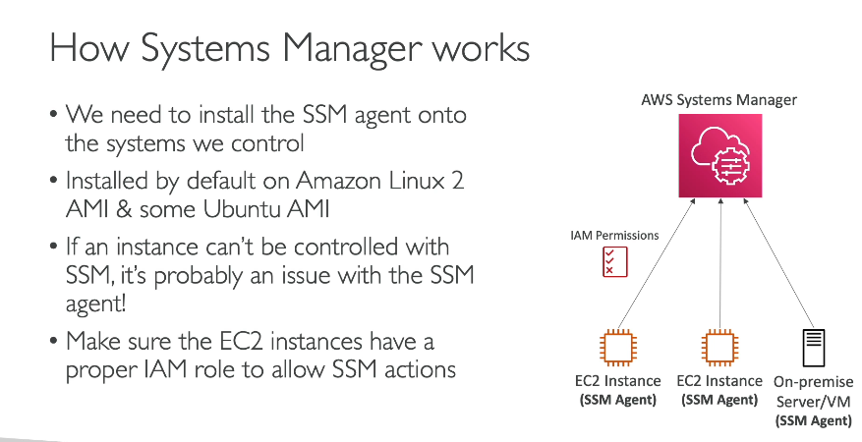
IAM Role Configuration:
- Assign an IAM role to your EC2 instance that includes the necessary permissions for Systems Manager. The AmazonEC2RoleforSSM managed policy is commonly used for this purpose. Ensure this role is attached to your instance.
Organizing your AWS resources using tags and resource groups enhances management efficiency and clarity. Here's how you can create resource groups based on tags:
1. Tagging Your Resources:
Begin by assigning consistent tags to your AWS resources. Tags are key-value pairs that help categorize resources. For example:
- Key: Environment
- Value: Production
You can add tags through the AWS Management Console, AWS CLI, or SDKs.
2. Creating a Resource Group Based on Tags:
Once your resources are tagged, follow these steps to create a resource group:
- Access the AWS Resource Groups Console:
  - Sign in to the AWS Resource Groups console.
- Initiate Group Creation:
  - In the navigation pane, select Create Resource Group.
- Define Group Criteria:
  - On the Create query-based group page, under Group type, choose Tag based group.
  - Under Grouping criteria, select the resource types you want to include (e.g., AWS::EC2::Instance, AWS::S3::Bucket).
  - Specify the tag key and value pairs that your resources share.
- Preview and Create:
  - Click Preview group resources to view the resources that match your criteria.
  - If the results are as expected, provide a name and description for your group under Group details.
  - Choose Create group to finalize.

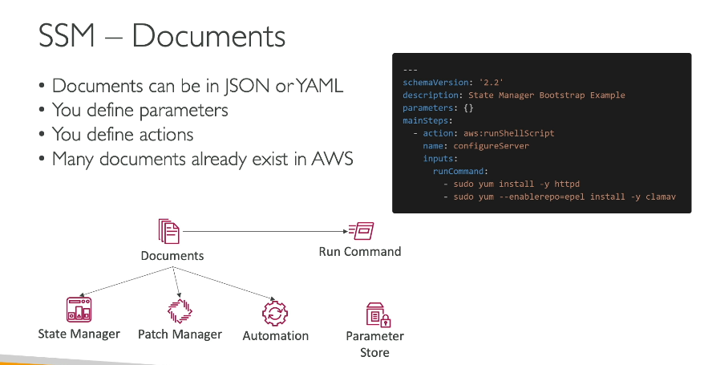

To create an EC2 instance and install HTTP (Apache) without allowing SSH in the security group, you can use AWS Systems Manager (SSM) for remote execution. This involves:
- Creating an EC2 instance with SSM Agent enabled
- SSH Document
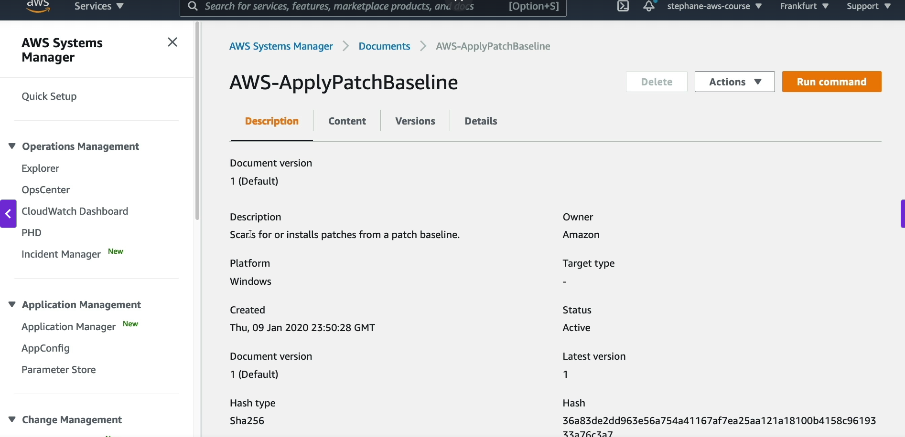

- Using AWS Systems Manager Run Command to install Apache
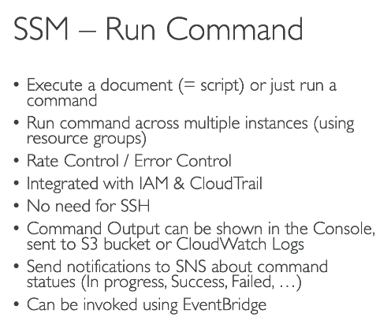
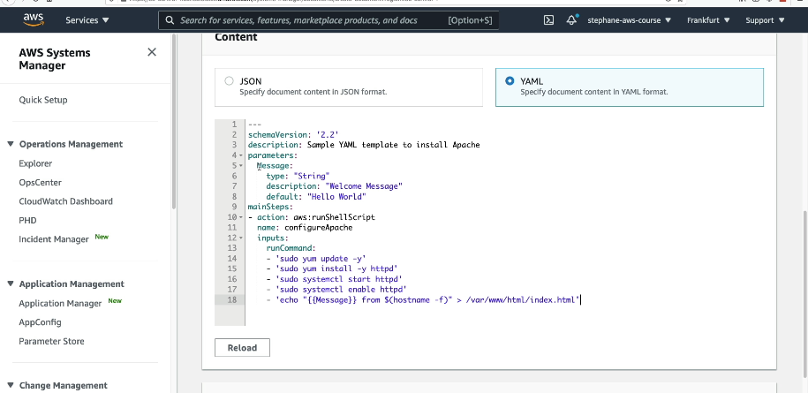
- Defining everything in JSON or YAML using AWS CloudFormation

AWS Systems Manager Automation is a feature within AWS Systems Manager that streamlines common maintenance and deployment tasks across AWS services such as Amazon EC2, Amazon RDS, and Amazon S3. It enables you to automate operational tasks, reducing manual intervention and enhancing efficiency.
Key Features:
- Predefined and Custom Runbooks: Automation provides a library of predefined runbooks (formerly known as Automation documents) for common tasks. You can also create custom runbooks tailored to your specific requirements.
- Step-by-Step Execution: Automations can be executed step by step, allowing for manual review and control at each stage. This is particularly useful for complex operations where validation is required between steps.
- Integration with AWS Services: Automation integrates seamlessly with other AWS services, enabling tasks such as instance resizing, AMI creation, and patch management to be performed automatically.
Getting Started:
- Access the Automation Console:
  - Navigate to the AWS Systems Manager console.
  - In the navigation pane, select Automation.
- Execute an Automation:
  - Choose Execute automation.
  - Select a predefined runbook or create a custom one.
  - Configure the necessary parameters and execute the automation.

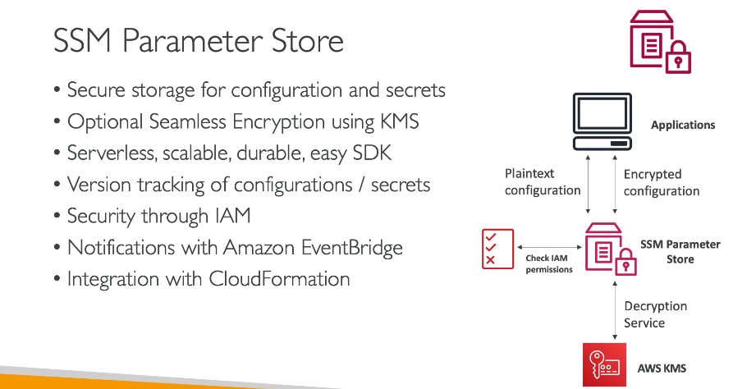
AWS Systems Manager (SSM) Parameter Store is a secure storage service that allows you to store, manage, and retrieve configuration data and secrets for your applications. It helps in managing environment variables, database credentials, API keys, and other sensitive information.
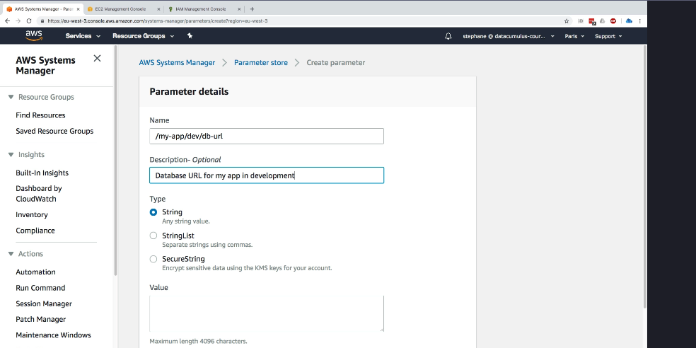

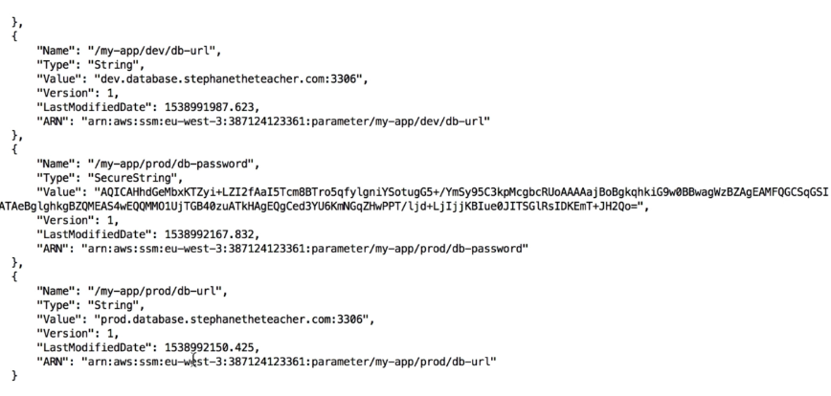
SSM Inventory
AWS SSM Inventory collects and stores metadata about your EC2 instances, such as:
✅ Installed applications
✅ OS versions and patches
✅ Network configurations
✅ Amazon Machine Image (AMI) details
🔹 Benefits of SSM Inventory
- Helps track instance configuration changes over time.
- Enables compliance auditing and reporting.
- Works across multiple AWS regions and accounts
SSM State Manager
AWS SSM State Manager helps you maintain the desired configuration of EC2 instances by applying policies, scripts, or patches automatically.
🔹 Benefits of State Manager
Ensures all instances stay in a consistent state.
Automates patching, configuration updates, and compliance checks.
Works with SSM Automation, Patch Manager, and Inventory.
🔹 Use Cases
✅ automatically install and update software (e.g., Apache, Nginx)
✅ Ensure security configurations (e.g., disable root login, enforce SSH key authentication)
✅ Enforce compliance rules (e.g., ensure all instances have a specific security group)
Real-World Example
Imagine you have 100 EC2 instances and want to:
1️Track software versions using SSM Inventory.
2️Automatically install updates using SSM State Manager.
3️ Ensure compliance by checking if security patches are installed.
This combination helps automate IT operations, improve security, and ensure all instances are correctly configured.

SSM Patch Management
AWS Patch Manager is used to scan and apply security updates to EC2 instances, ensuring compliance with security policies.
🔹 Benefits of Patch Manager
✅ Automatically installs OS and application updates.
✅ Schedules patching during non-business hours to avoid downtime.
✅ Works across multiple instances, accounts, and AWS regions.
🔹 How Patch Manager Works
1️Define a Patch Baseline – Specifies approved patches.
2️Scan EC2 Instances – Checks for missing patches.
3️Apply Patches – Installs required updates based on the defined schedule.

SSM Maintenance Windows
A Maintenance Window schedules tasks such as patching, script execution, and configuration updates during a predefined period.
🔹 Benefits of Maintenance Windows
✅ Ensures patching happens outside business hours.
✅ Reduces downtime by scheduling updates at the best time.
✅ Automates tasks like patching, software updates, and backups.

SSM Session Manager: Secure SSH & Shell Access to EC2 Instances Without Using Keys or Bastion Hosts
🔹 Scenario: Securely Accessing Your ChatApp Backend Without SSH Keys
You have a Django backend running on EC2 instances behind a Load Balancer. Normally, you would use SSH with key pairs to access your servers. However:
✅ You don’t want to manage SSH keys.
✅ You need a secure way to access instances in a private subnet.
✅ You want centralized logging of all SSH sessions.
🔹 Solution: AWS SSM Session Manager
AWS Systems Manager (SSM) Session Manager lets you connect to EC2 instances securely without SSH keys or opening port 22. Instead, you access them directly from the AWS Console or CLI.
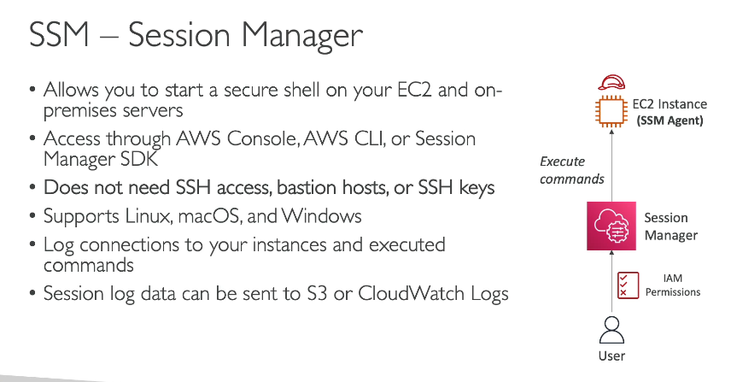
Your EC2 instance needs permission to allow SSM to manage it.
Create an IAM Role for SSM:
